SIMATS ENGINEERING
ASSESSMENT TOOL 1: Algorithm Design Challenge
COURSE NAME: ARTIFICIAL INTELLIGENCE COURSE CODE: MLA01
AND EXPERT SYSTEMS

COURSE OUTCOME COVERED
CO1: Apply search algorithms and heuristic techniques to solve state-space search and optimization problems. (BTL 3)
Assessment Tool Weightage: 40 %

Total Marks: 100 Time: 90 Mins
No. of Questions: 5
Annexure A
Algorithm Design Challenge

Code of Conduct:

I P Dinesh Reddy /192525399 (Name / Reg No) certify that this submission is my original work and that I have adhered to the guidelines specified for this assessment. I understand that any violation of academic integrity rules will result in disciplinary action.

Signature of the student:

Criterion | Weightage | Marks Obtained
Problem Analysis and Understanding | 15%
AI Algorithm Selection & Justification | 15%
Algorithm Design / Pseudocode | 25%
Application of AI Concepts (Greedy, A*, CSP, Minimax, etc.) | 15%
Diagram / State Space / Search Tree Representation | 10%
Complexity Analysis and Solution Efficiency | 10%
Originality, Critical Thinking, and Presentation | 10%
Total | 100%

Signature of the Faculty Total Marks Awarded Answer all the Questions

Q.No | Question | Topics
1 | Design an algorithm using Greedy Best-First Search to find a path from a source node to a goal node for the given Romania Map Problem graph. Clearly define the heuristic function, show the node expansion order, and justify why Greedy Best-First Search is suitable for this problem. | Informed Search,  Greedy Best-First  Search, Heuristic  Functions
2 | A delivery robot must travel from a warehouse to a customer through a weighted road network. Design an A Search algorithm to determine the optimal path. Calculate g(n), h(n), and f(n) for each expanded node, and explain why A guarantees the optimal solution. | A* Search,  Heuristic  Functions
3 | A university needs to prepare an examination timetable without scheduling conflicting subjects at the same time. Design the problem as a Constraint Satisfaction Problem (CSP) by identifying variables, domains, and constraints. Explain how MRV and Forward Checking improve the efficiency of the solution. | CSP, MRV,  Forward  Checking
4 | Design the Minimax algorithm for the given game tree to determine the best move for the MAX player. Then apply Alpha–Beta Pruning to the same tree and indicate which nodes are pruned. Compare the number of nodes evaluated before and after pruning. | Game Playing,  Minimax,  Alpha–Beta  Pruning
5 | A warehouse robot operates in a dynamic environment where obstacles may appear unexpectedly. Design an intelligent search strategy using either Local Search or an Online Search Agent. Explain how the algorithm adapts to environmental changes and compare its performance with informed search algorithms. | Local Search,  Optimization,  Online Search  Agents

Structure of the Answer – Algorithm Design Challenge

S.No | Sections | Expected Content
1 | Problem Statement | Briefly describe the given problem in your own words.
2 | Problem Analysis | Identify the initial state, goal state, assumptions, and constraints.
3 | AI Technique Selection | Specify the most appropriate AI algorithm/search technique (e.g., Greedy Best-First Search, A*, CSP, Minimax, Local Search).
4 | Justification of Algorithm | Explain why the selected algorithm is suitable compared to other search techniques.
5 | State Space Representation | Represent the problem using a state-space diagram, search graph, game tree, or constraint graph, as applicable.
6 | Variables, Domains, and  Constraints (Applicable for  CSP problems) | Identify variables, possible domains, and constraints. If not applicable, mention "Not Applicable".
7 | Heuristic Function  (Applicable for Informed  Search) | Define the heuristic function h(n) and explain whether it is admissible or appropriate for the problem. If not applicable, mention "Not Applicable".
8 | Algorithm Design /  Pseudocode | Write the step-by-step algorithm or pseudocode for solving the problem.
9 | Flowchart / Algorithm  Diagram | Draw a flowchart, search tree, game tree, or algorithm workflow illustrating the solution.
10 | Working / Execution Trace | Demonstrate the execution of the algorithm with at least one example, showing intermediate steps such as node expansion, constraint propagation, or game-tree evaluation.
11 | Complexity Analysis | Analyze the Time Complexity and Space Complexity of the proposed algorithm.
12 | Advantages and  Limitations | Discuss the strengths and limitations of the selected algorithm for the given problem.
13 | Conclusion | Summarize the effectiveness of the designed algorithm and suggest possible improvements or alternative approaches.

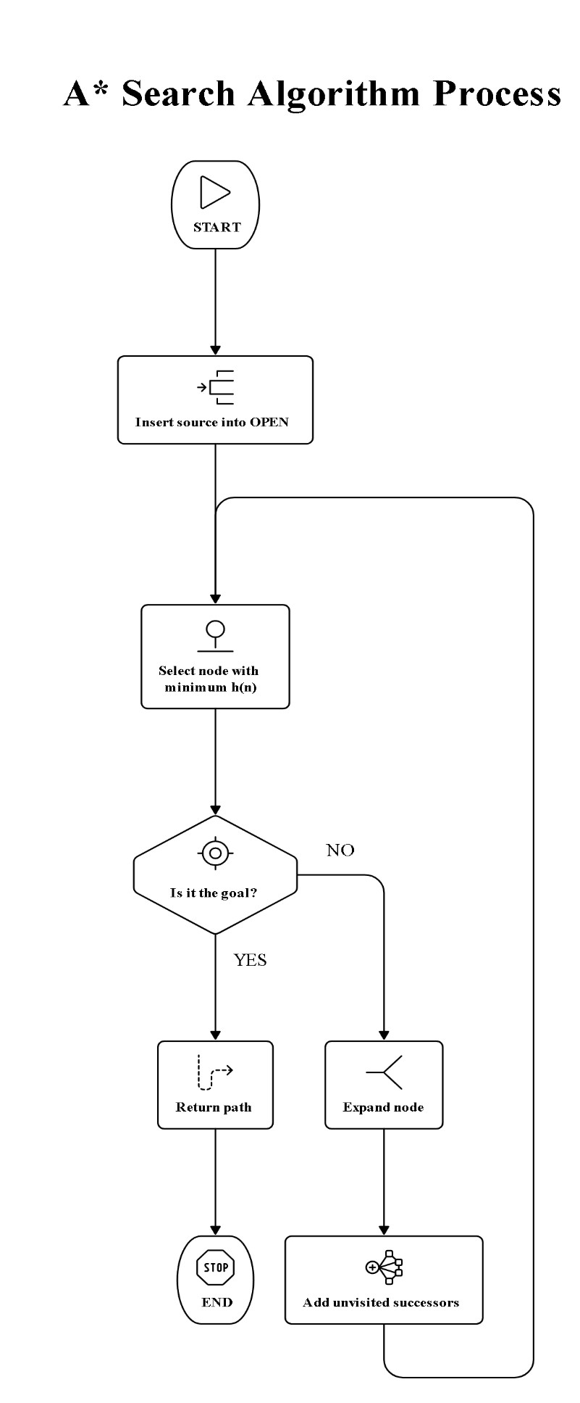
Greedy Best-First Search – Romania Map Problem
- Problem Statement:
Find a path from the source city to the goal city using Greedy Best-First Search.
- Problem Analysis: Initial state: Arad; Goal state: Bucharest;
Constraint: choose the lowest heuristic value.
- AI Technique Selection:
Greedy Best-First Search (GBFS).
- Justification of Algorithm:
GBFS quickly selects the node estimated closest to the goal using h(n).
- State Space Representation:
Cities are nodes and roads are edges forming the Romania state-space graph.
- Variables, Domains, and Constraints: Not Applicable.
- Heuristic Function:
h(n) = straight-line distance from city n to Bucharest.
8.Algorithm Design / Pseudocode:
  - Start with source node in OPEN.
  - Set CLOSED as empty.
  - Select the node with minimum h(n).
  - If node is the goal, return the path.
  - Otherwise, expand the selected node.
  - Add unvisited successors to OPEN.
  - Move the selected node to CLOSED.
  - Repeat until the goal is reached.

- Working / Execution Trace:
Arad → Sibiu → Fagaras → Bucharest, selecting the smallest h(n) at each step.
- Complexity Analysis: Time: O(bᵐ); Space: O(bᵐ), where b is branching factor.
- Advantages and Limitations: Fast and simple, but it does not guarantee the shortest path.
- Conclusion: GBFS efficiently reaches
Bucharest by prioritizing nodes with minimum heuristic distance.

A* Search – Delivery Robot
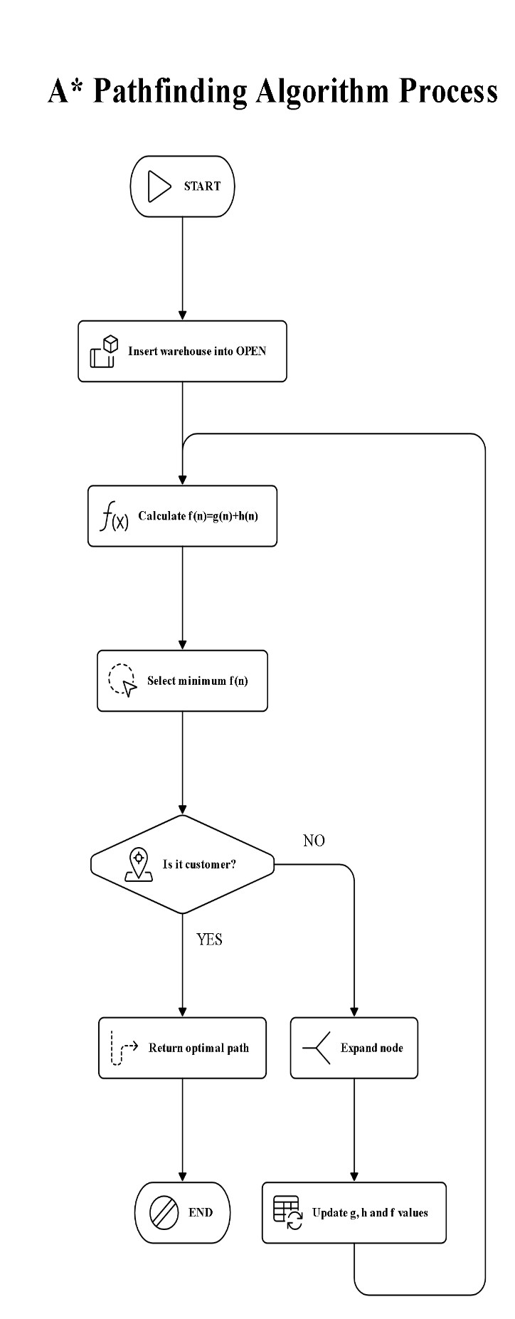
1. Problem Statement:
Find the optimal route from warehouse to
2.
customer using A* Search.
- Problem Analysis:
Initial state: Warehouse; Goal state: Customer; roads have different costs.
- AI Technique Selection: A* Search algorithm.
- Justification of Algorithm:
A* combines actual cost and heuristic cost to find an optimal path.
- State Space Representation:
Locations are nodes and weighted roads are edges.
- Variables, Domains, and Constraints: Not Applicable.
- Heuristic Function:
h(n) estimates the remaining cost from node n to the customer.
- Algorithm Design / Pseudocode:
  - Insert the warehouse into OPEN.
  - Set g(start) = 0.
  - Calculate f(n) = g(n) + h(n).
  - Select the node with minimum f(n).
  - If it is the goal, return the path.
  - Expand the selected node.
  - Update g(n), h(n), and f(n) for successors.
8.Repeat until the goal is reached.
- Working / Execution Trace:
At each step, calculate f(n)=g(n)+h(n) and expand the node with minimum f(n).
- Complexity Analysis:
Time: O(bᵈ); Space: O(bᵈ), where b is branching factor.
- Advantages and Limitations:
A* is optimal with an admissible heuristic but requires more memory.
- Conclusion:
A* efficiently determines the optimal delivery route using cost and heuristic information.

CSP – University Examination Timetable
Problem Statement:
Create an examination timetable without scheduling conflicting subjects together.
- Problem Analysis: Variables are subjects, domains are available time slots, and conflicts are constraints.
- AI Technique Selection:
Constraint Satisfaction Problem (CSP).
- Justification of Algorithm: CSP efficiently assigns time slots while satisfying all scheduling constraints.
- State Space Representation: Each node represents a subject assignment and branches represent possible time slots.
- Variables, Domains, and Constraints:
Variables: Subjects; Domain: Time slots; Constraints: Conflicting subjects cannot share a slot.
- Heuristic Function:
Not Applicable.
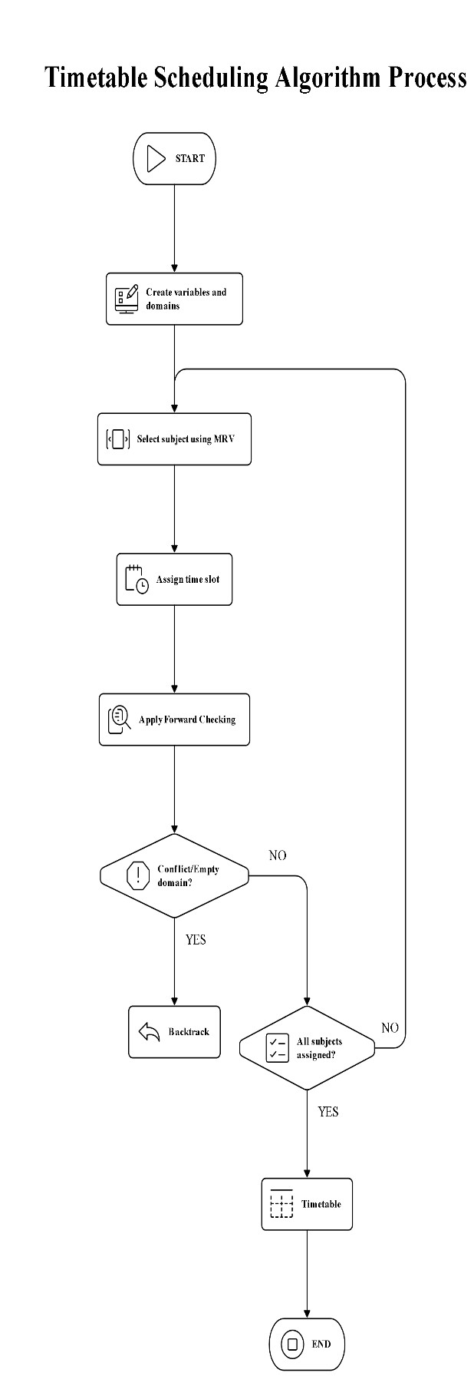
- Algorithm Design / Pseudocode:
- Identify all subjects and available time slots.
- Assign each subject a domain of possible slots.
- Select the variable using MRV.
- Assign a valid time slot.
- Apply Forward Checking to remove conflicting values.
- If a domain becomes empty, backtrack.
- Continue until all subjects are assigned. 8. Return the valid examination timetable.
- Working / Execution Trace: MRV selects the most constrained subject first, while Forward Checking removes conflicting slots.
- Complexity Analysis:
Worst-case time: O(dⁿ); space: O(n), excluding stored search states.
- Advantages and Limitations:
CSP reduces unnecessary search but may require backtrackingfor difficult conflicts.
13.Conclusion:
CSP with MRV and Forward Checking produces a conflict-free timetable efficiently.

Minimax – Alpha–Beta Pruning
- Problem Statement:
Determine the best move for MAX using Minimax and Alpha–Beta Pruning.
- Problem Analysis:
MAX maximizes the score while MIN minimizes the score.
- AI Technique Selection:
Minimax with Alpha–Beta Pruning.
- Justification of Algorithm:
Minimax selects the optimal move, while Alpha– Beta reduces unnecessary evaluations.
- State Space Representation:
The game is represented as a tree with MAX, MIN, and terminal nodes.
- Variables, Domains, and Constraints:
Not Applicable.
- Heuristic Function:
Not Applicable.
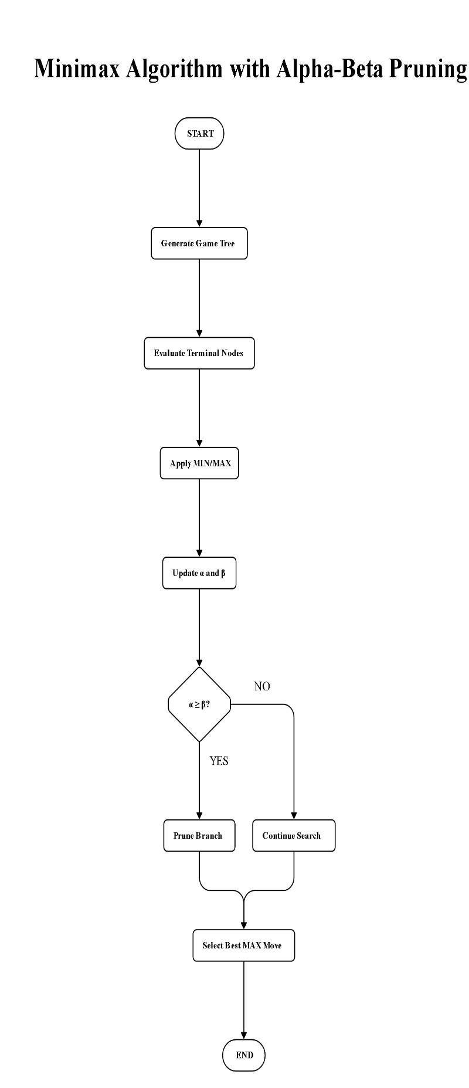
- Algorithm Design / Pseudocode:
- Start at the root MAX node.
- Generate all possible game states.
- Evaluate terminal nodes.
- MAX selects the highest value.
- MIN selects the lowest value.
- Maintain alpha and beta values.
- Prune branches when alpha ≥ beta.
- Return the best value and move for MAX.
- Working / Execution Trace:
Minimax evaluates leaf values upward; Alpha–Beta skips branches that cannot affect the final decision.
- Complexity Analysis:
Minimax: O(bᵈ); Alpha–Beta best case: O(bᵈᐟ²).
- Advantages and Limitations:
Alpha–Beta reduces computation but its efficiency depends on move ordering.
- Conclusion:
Minimax finds the optimal MAX move, while Alpha–Beta achieves it with fewer evaluations.

Online Search Agent – Warehouse Robot
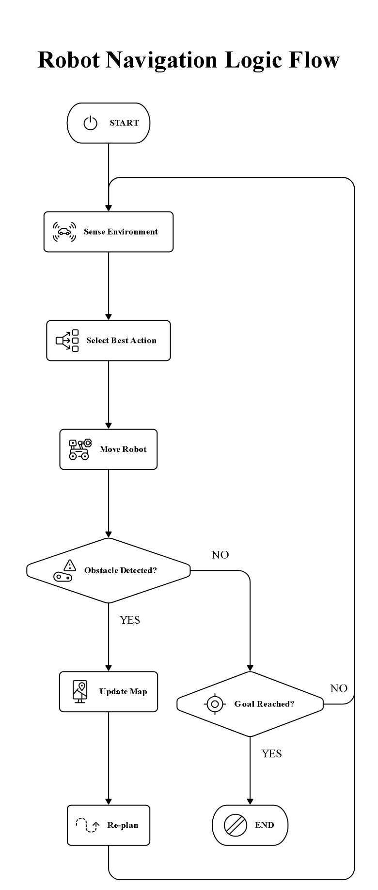
- Problem Statement:
Enable a warehouse robot to reach its destination despite changing obstacles.
- Problem Analysis:
Initial state: Robot position; Goal state: Destination; constraint: unexpected obstacles.
- AI Technique Selection: Online Search Agent.
- Justification of Algorithm:
Online search adapts decisions using information obtained while moving.
- State Space Representation:
Robot positions are states and movements between positions are actions.
- Variables, Domains, and Constraints:
Not Applicable.
- Heuristic Function:
Not Applicable.
- Algorithm Design / Pseudocode:
- Start from the robot's current position.
- Sense the surrounding environment.
- Select the best available action.
- Move to the selected position.
- Observe newly discovered obstacles.
- Update the search information.
- Re-plan the route when conditions change.
- Repeat until the goal is reached.
- Working / Execution Trace:
The robot senses an obstacle, updates its route, and continues toward the goal using the new information.
- Complexity Analysis:
Time and space depend on the explored states and environmental changes.
- Advantages and Limitations:
Adapts to dynamic environments but may require repeated planning.
- Conclusion: Online search provides flexible navigation when warehouse conditions change unexpectedly.

EVALUATION RUBRICS

Criteria | Weightage  (%) | Excellent (90–100%) | Good (75–  89%) | Average (60–  74%) | Poor (<60%)
Problem  Analysis and  Understanding | 15% | 13–15% –  Clearly identifies the problem, initial state, goal state, constraints, and expected outcome. | 10–12% –  Identifies most problem components with minor omissions. | 7–9% – Demonstrates  partial understanding with some missing. | 0–6% – Incorrect or incomplete understanding of the problem.
AI Algorithm  Selection &  Justification | 15% | 13–15% –  Selects the most appropriate AI algorithm/searc h technique with strong technical justification. | 10–12% – Selects an appropriate algorithm with adequate | 7–9% –  Selects a partially suitable algorithm with limited justification. | 0–6% – Incorrect algorithm selection or no justification.
Algorithm  Design /  Pseudocode | 25% | 22–25% – Designs a complete, logical, efficient, and error-free algorithm/pseu docode. | 17–21% – Algorithm is mostly correct with minor logical errors. | 12–16% – Algorithm is partially complete with several logical errors. | 0–11% – Algorithm is incomplete, incorrect, or difficult to understand.
Application of  AI Concepts  (Greedy, A*,  CSP, | 15% | 13–15% – Correctly applies the relevant AI concepts and techniques throughout the solution. | 10–12% – Applies AI concepts correctly with | 7–9% –  Demonstrates limited application of AI concepts. | 0–6% – Unable to apply the appropriate AI concepts or techniques.
Diagram /  State  Space / Search  Tree | 10% | 9–10% – Accurate, complete, and well-labelled diagram supporting the solution. | 7–8% – Diagram is mostly correct with minor omissions. | 5–6% – Diagram  is partially complete or lacks clarity. | 0–4% – Diagram is missing or incorrect.
Complexity  Analysis and  Solution  Efficiency | 10% | 9–10% – Correctly analyzes time and space complexity and proposes an efficient solution. | 7–8% –  Complexity analysis is mostly | 5–6% –  Partial complexity analysis or limited | 0–4% – No meaningful complexity analysis or highly inefficient solution.

